**Ideation Phase**

**Define the Problem Statements**

|  |  |
| --- | --- |
|  |  |
| Team ID | NM2025TMID07828 |
| Project Name | Optimizing User, Group, and Role  Management with Access Control and Workflows |
| Maximum Marks | 2 Marks |

**Customer Problem Statement Template:**

**Problem Statement:**

Alice and Bob, a two-person project team using ServiceNow, face ongoing challenges due to undefined roles, weak access controls, and the absence of structured task workflows. This causes role confusion, delayed task execution, and limited project transparency. Without an automated system that aligns permissions with roles and tracks assignments efficiently, the team struggles to stay on top of deliverables. Their ideal solution includes intelligent role management, dynamic workflows, and real-time status visibility, helping them enhance collaboration, accountability, and project outcomes.

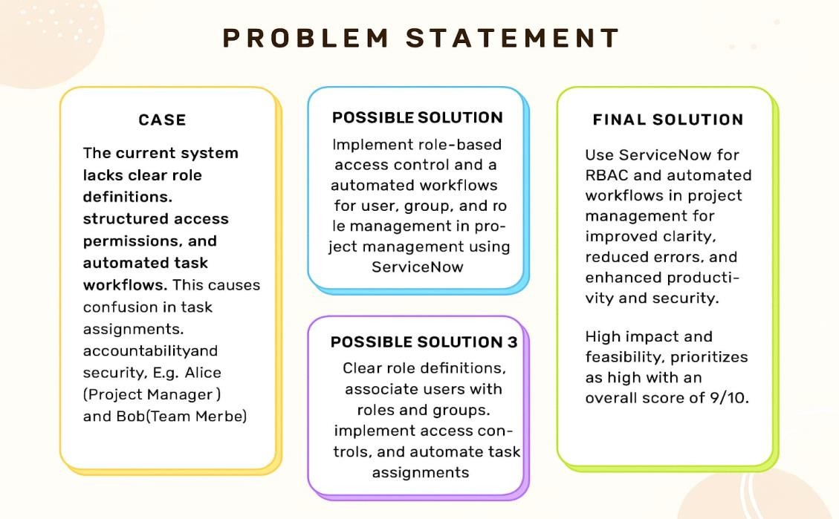

**Example**

|  |  |  |  |  |  |
| --- | --- | --- | --- | --- | --- |
| **Problem**  **Statement (PS)** | **I am**  **(Customer)** | **I’m trying to** | **But** | **Because** | **Which makes me feel** |
| PS-1 | Project  Manager  (Alice) | Manage tasks and track progress efficiently. | Lack clarity on  task ownershi p and status. | No defined roles, access controls, or structured workflows. | Confused, inefficient, accountable (difficult to track), frustrated |
| PS-2 | Team  Member  (Bob) | Understand and report assigned task s clearly. | Unclear responsib  ilities and update    process. | No clear task guidelines or progress tracking met hod. | Chaotic, slow, unclear, frustrated Anxious, tense, lost |